Deep Learning

* Md Zeaul Haque 1RV20CS086

**Image Classification**

Using concept of Transfer Learning

**LAYOUT OF THE DIRECTORIES AND PHOTOS THEY CONTAIN**

The path of the main folder ‘MEANS OF TRANSPORT’:

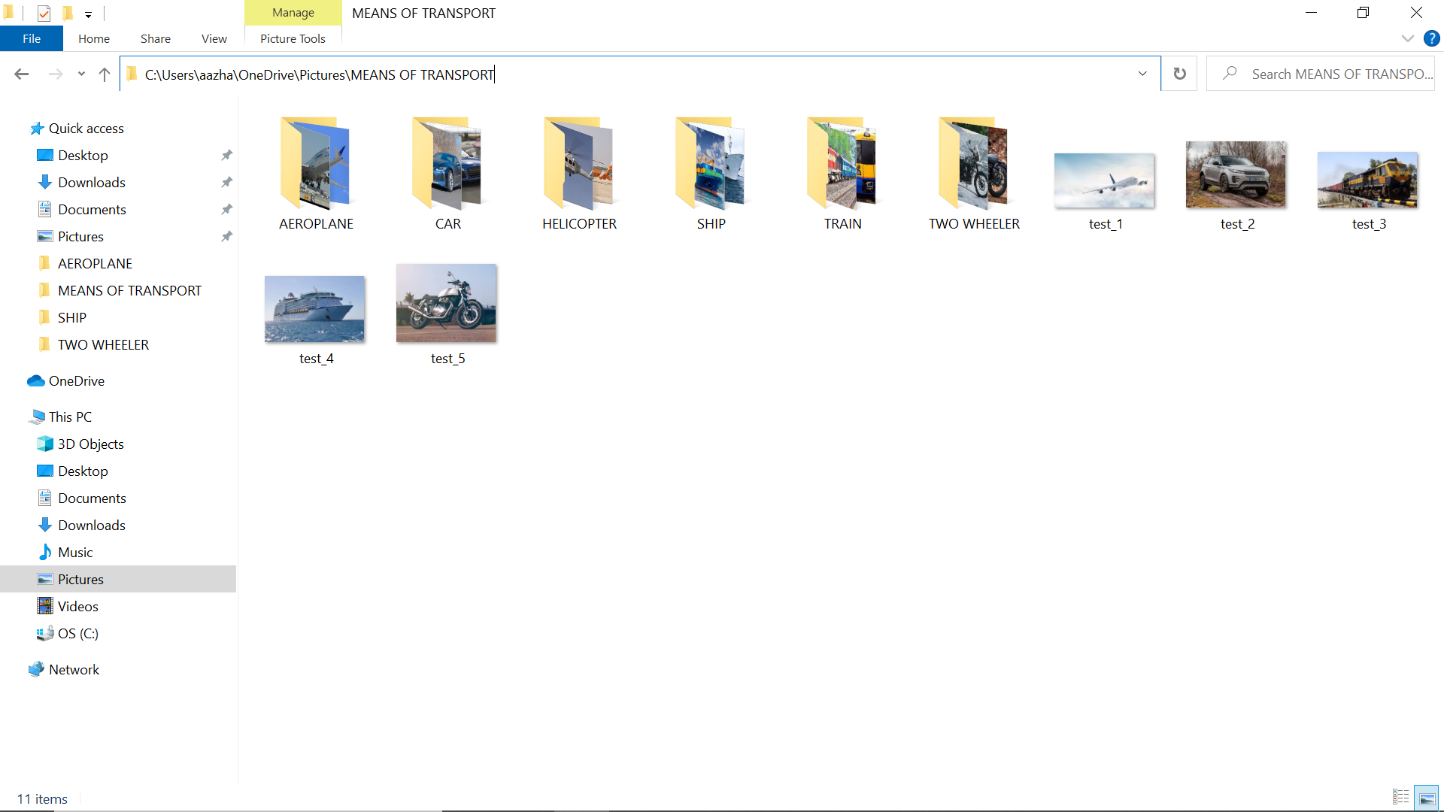

‘MEANS OF TRANSPORT’ contains 6 subfolders and 5 extra test images:

Each of the 6 subfolders contain 20 corresponding images (to be used for training purposes).

* AEROPLANE

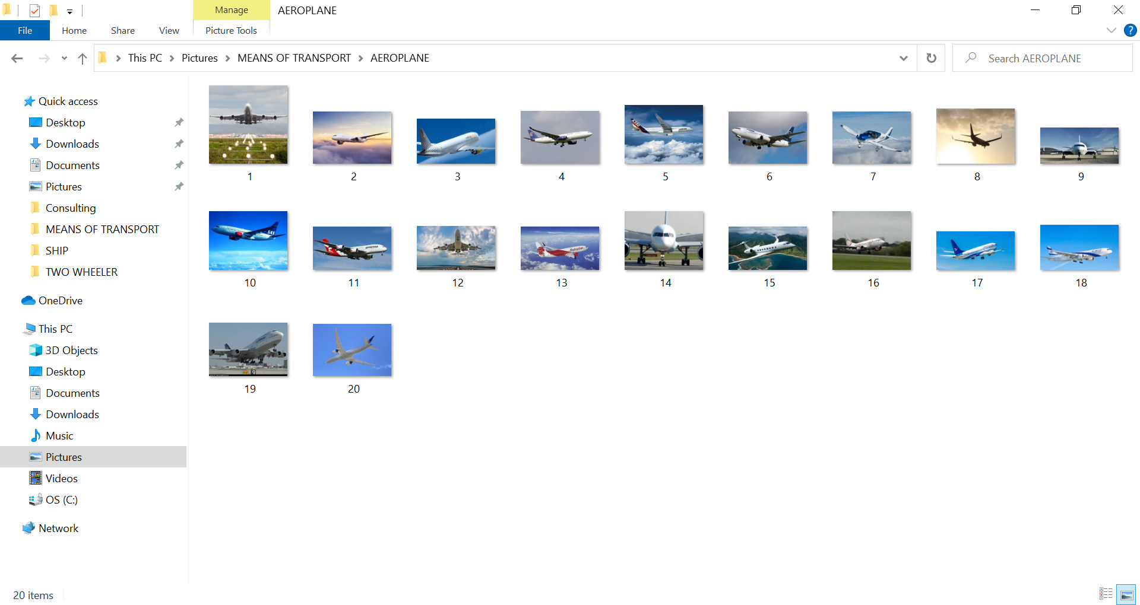

* CAR

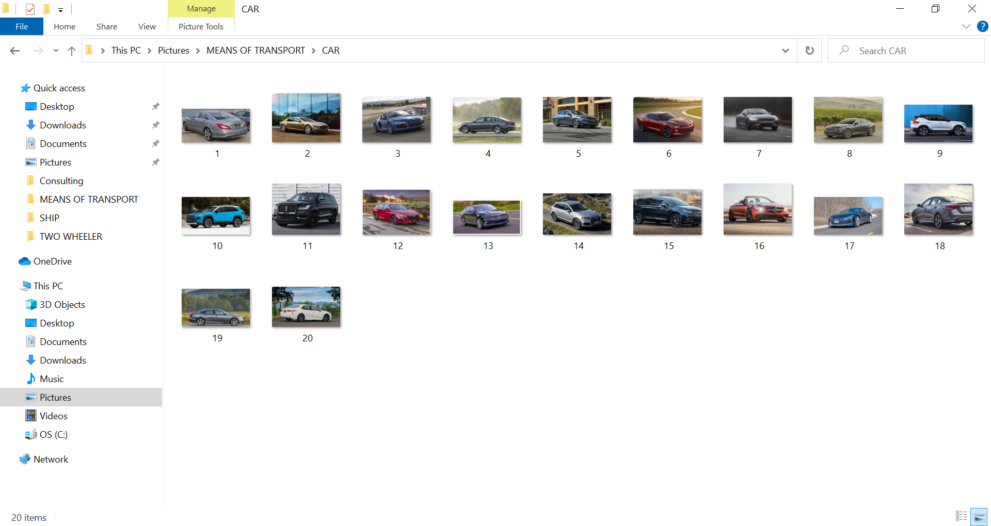

* HELICOPTER

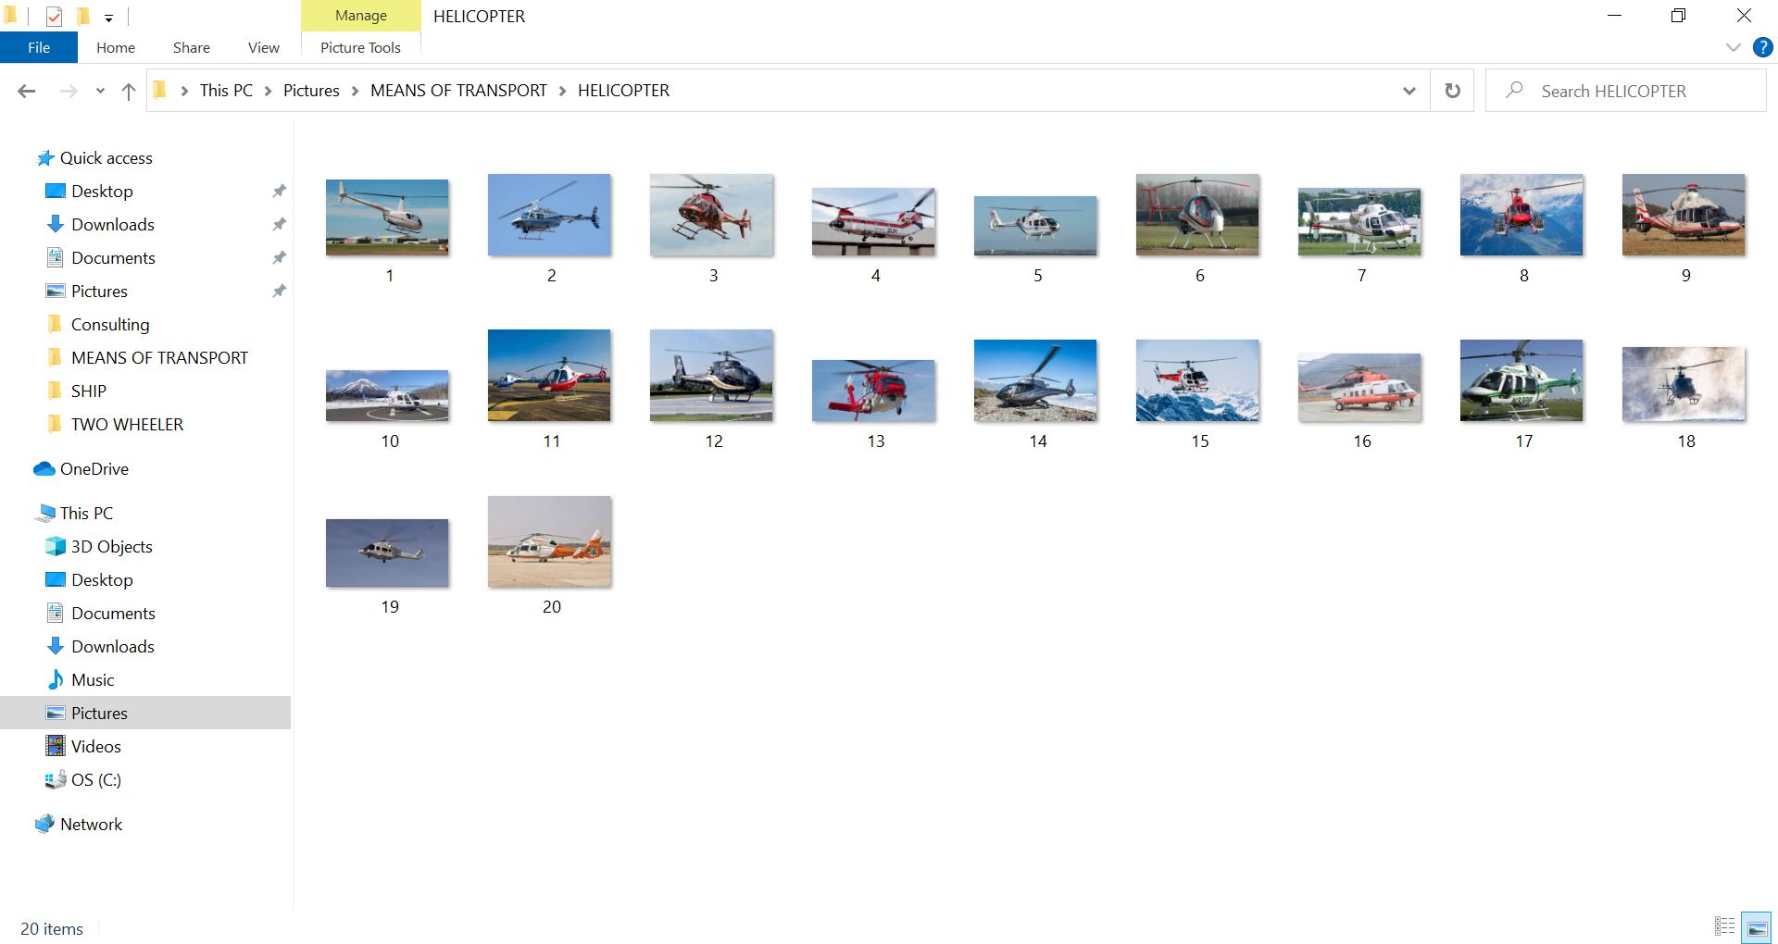

* SHIP

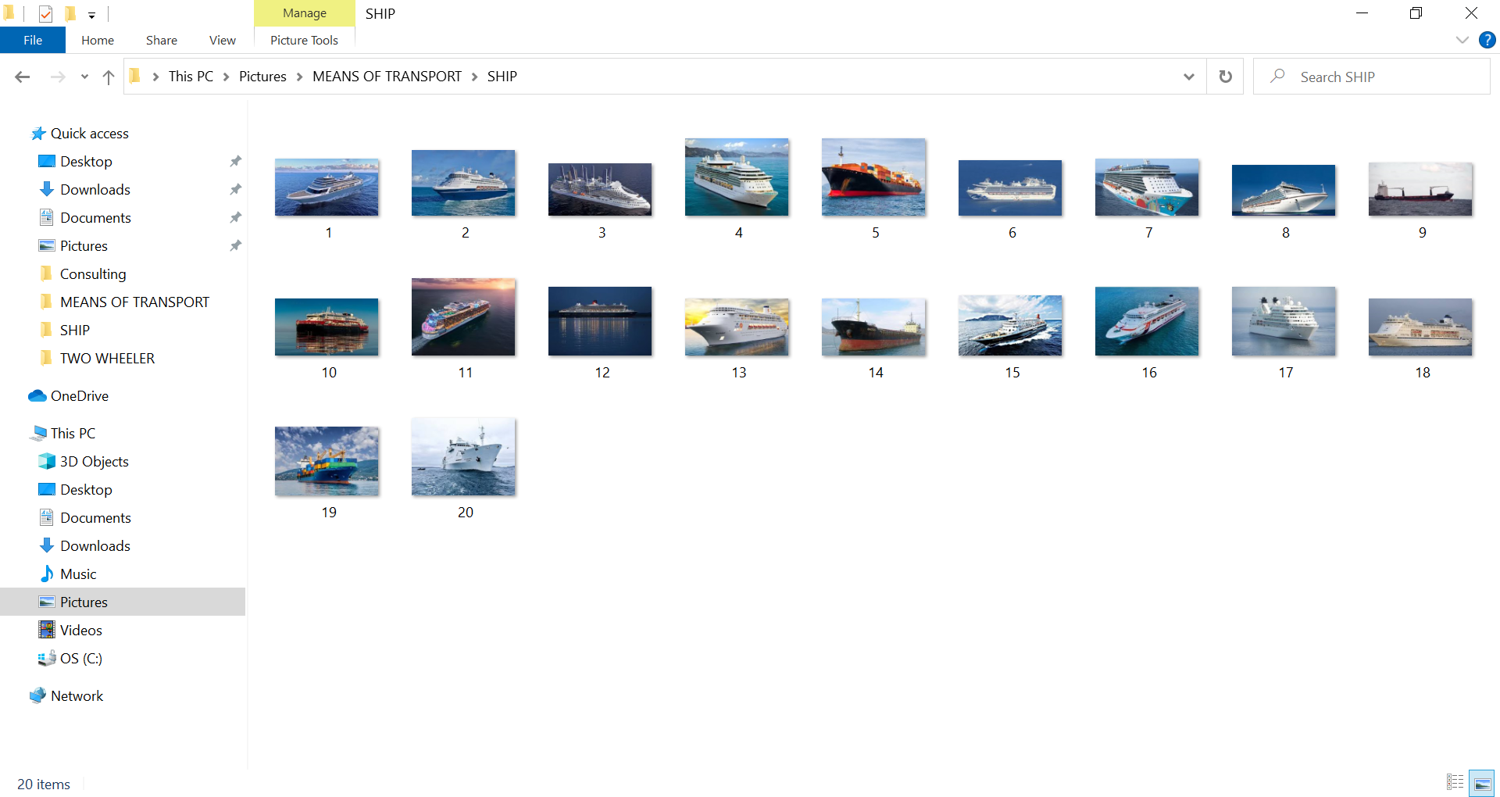

* TRAIN

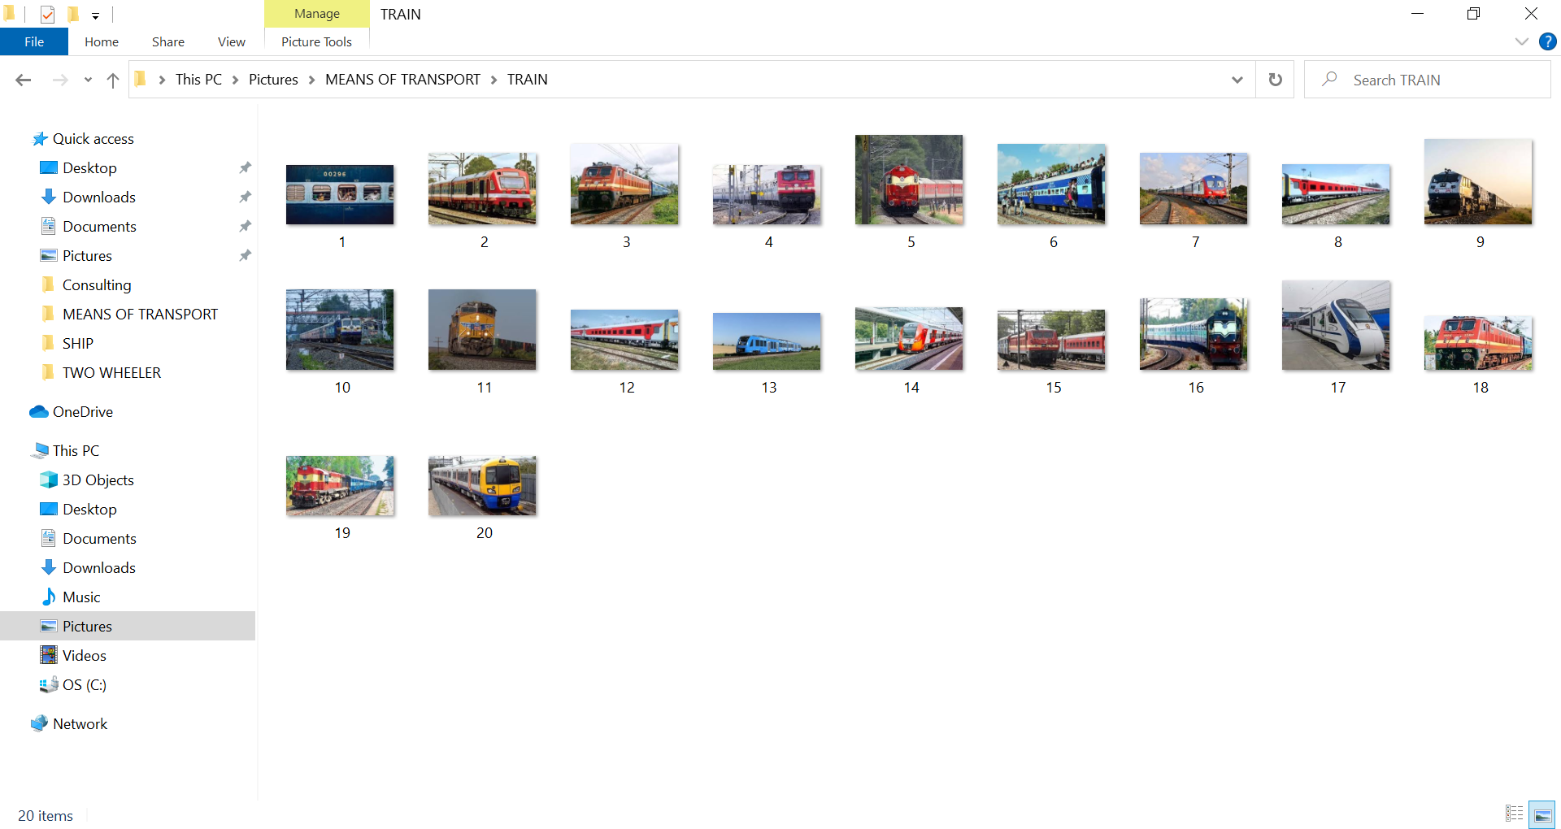

* TWO WHEELER

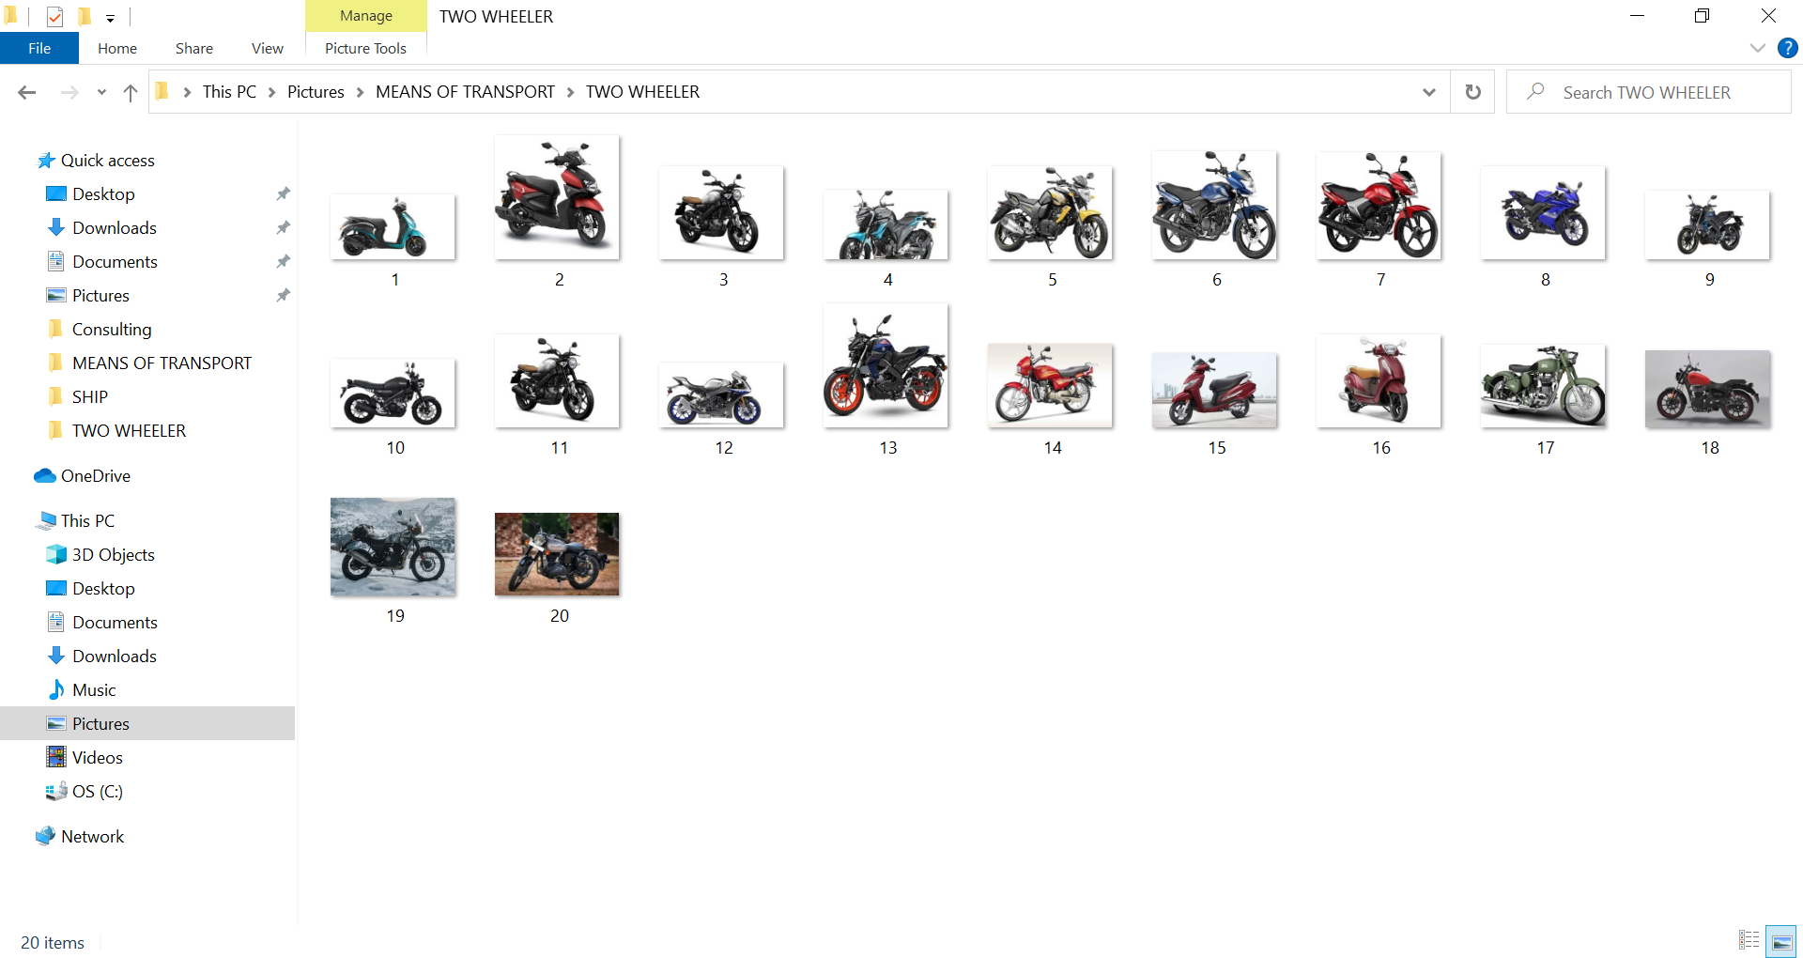

* 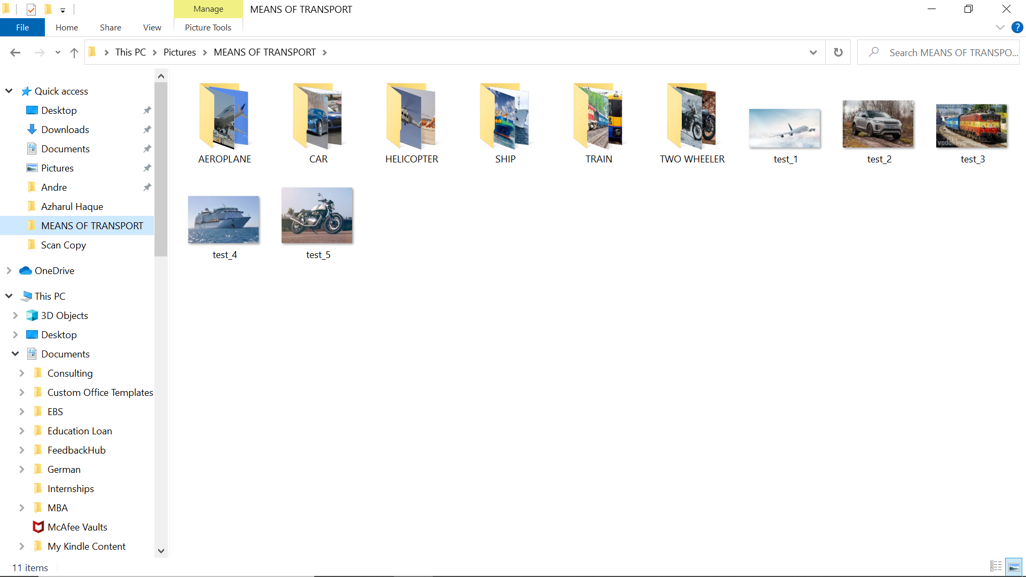5 TESTING IMAGES

**CODE**

1. 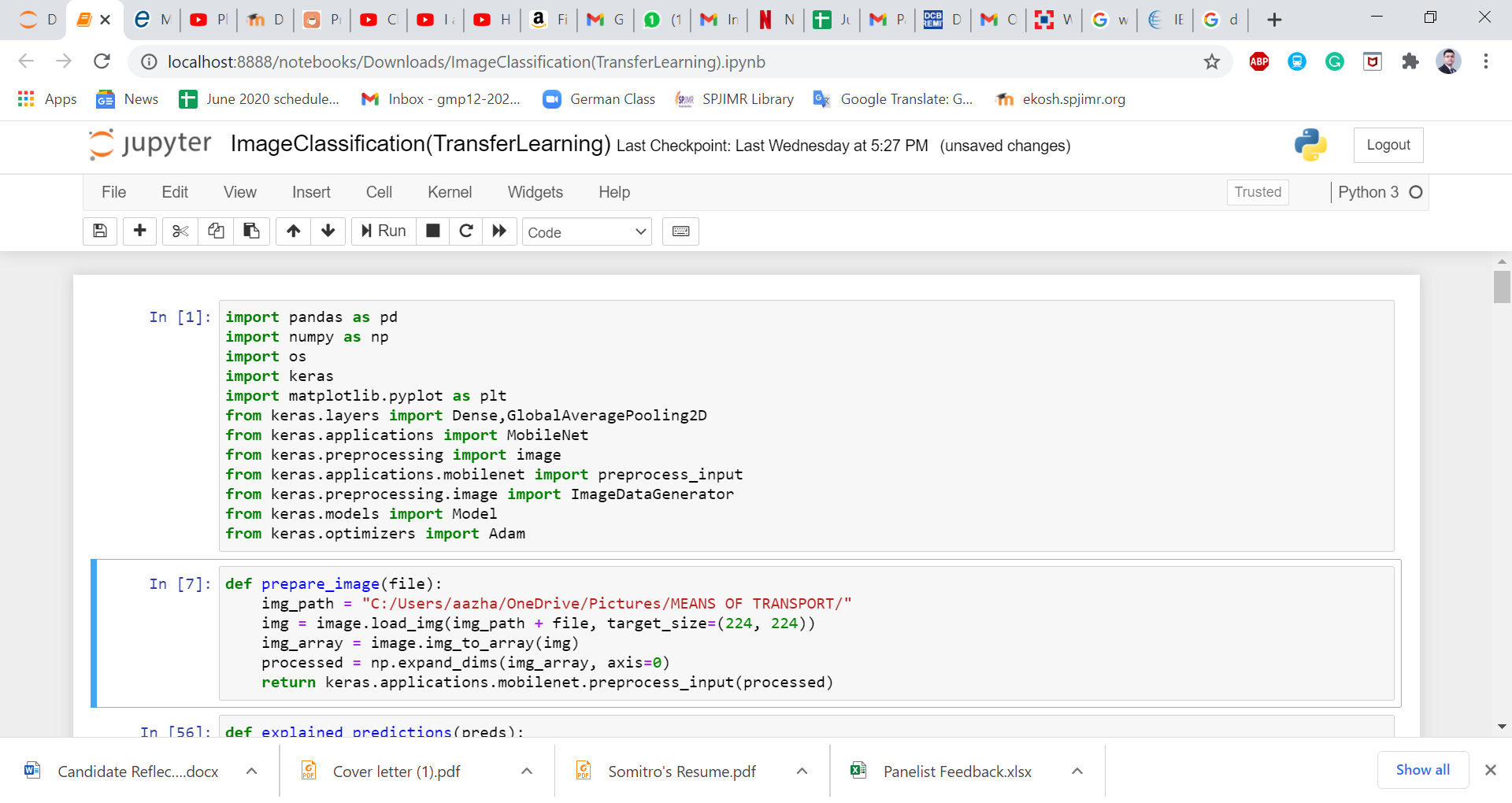Import all the required packages and libraries.
2. 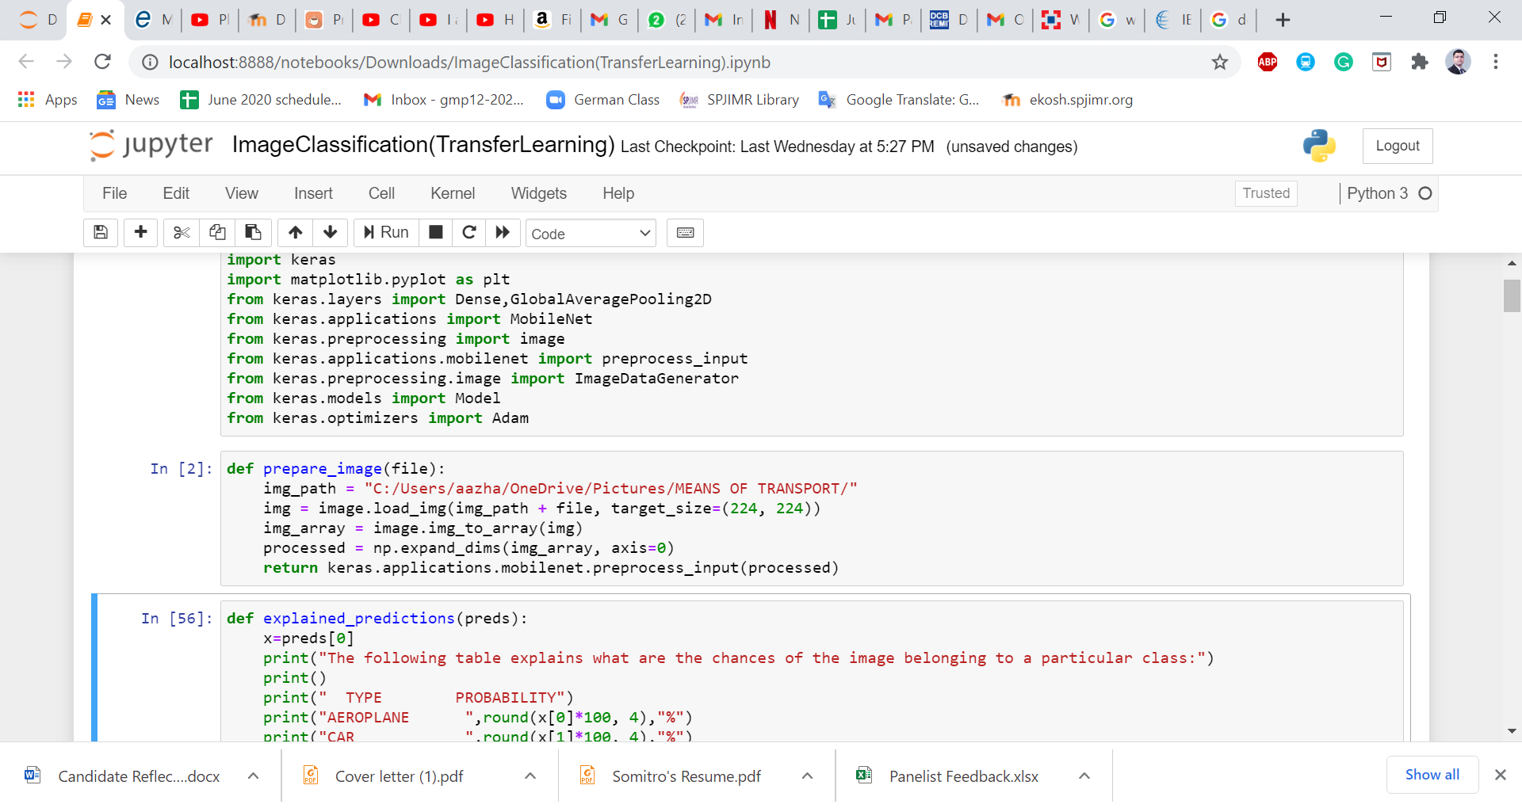Every time we feed an image to the model for testing, it will require pre-processing. So, we have defined a function that we will call as required.
3. 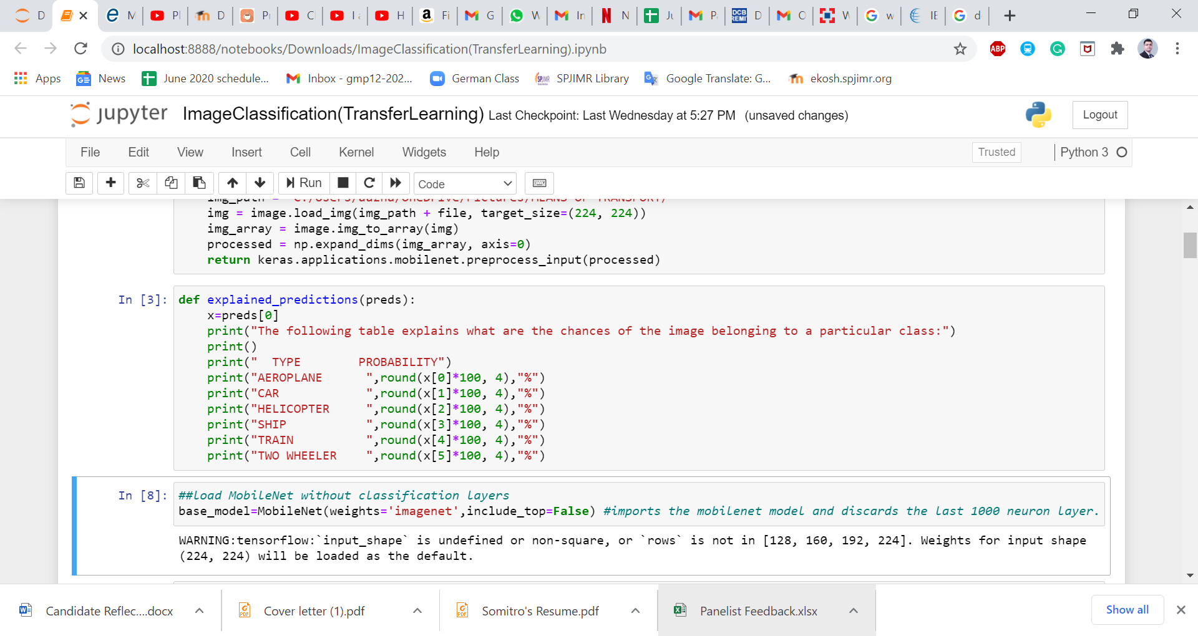Our model is a non-Imagenet model, so the pre-defined function decode_predictions() will not work. To be able to understand the predictions, we have defined a new function: explained_predictions().
4. 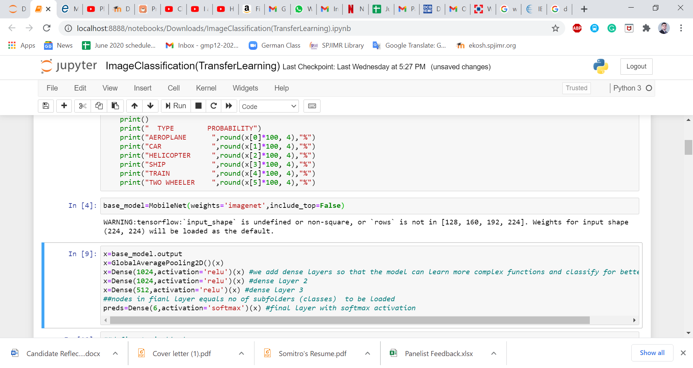We load the MobileNet model without the classification layers.
5. Now, we add dense layers so that the model can learn more complex functions and classify for better results.

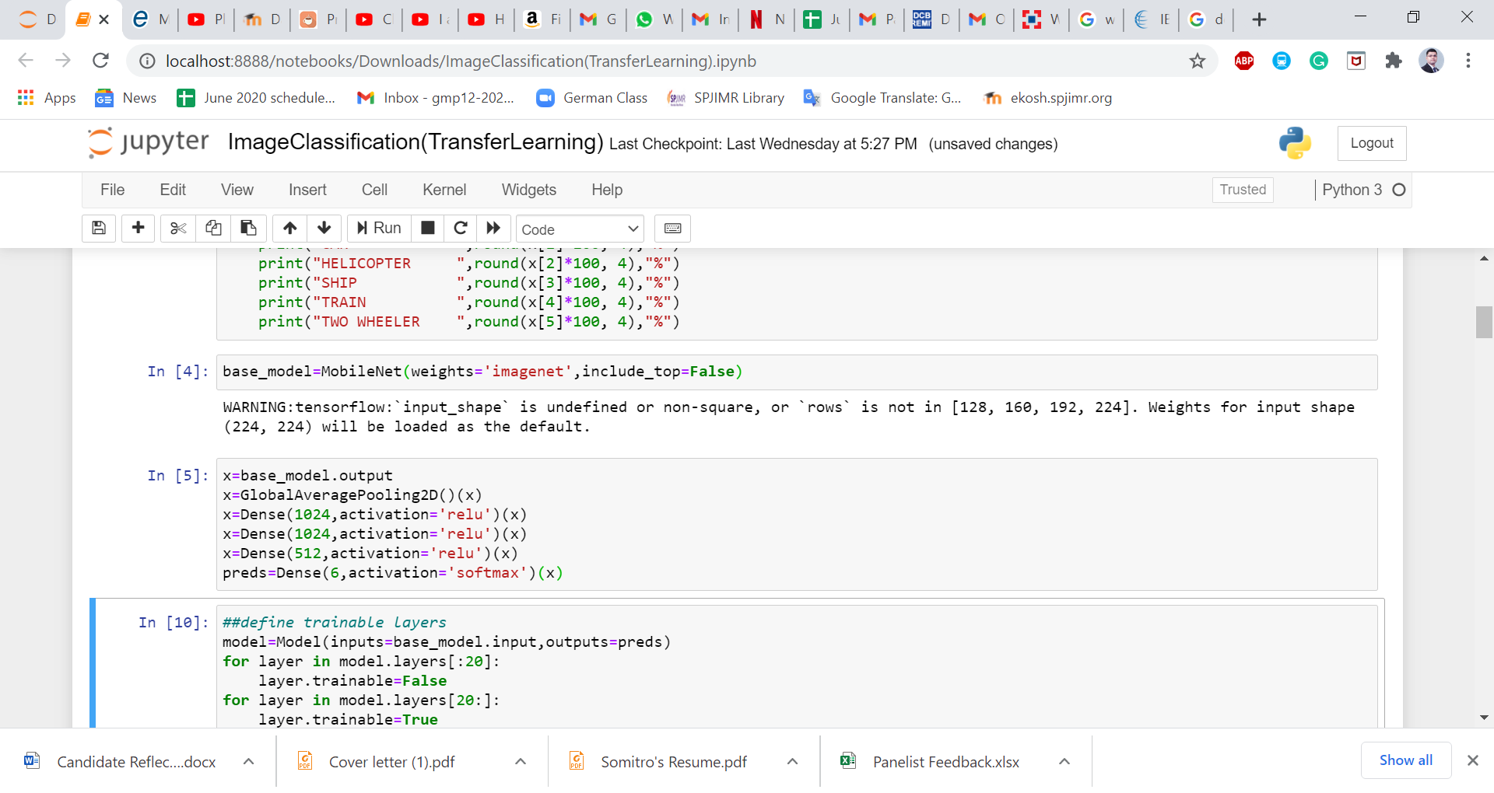

1. 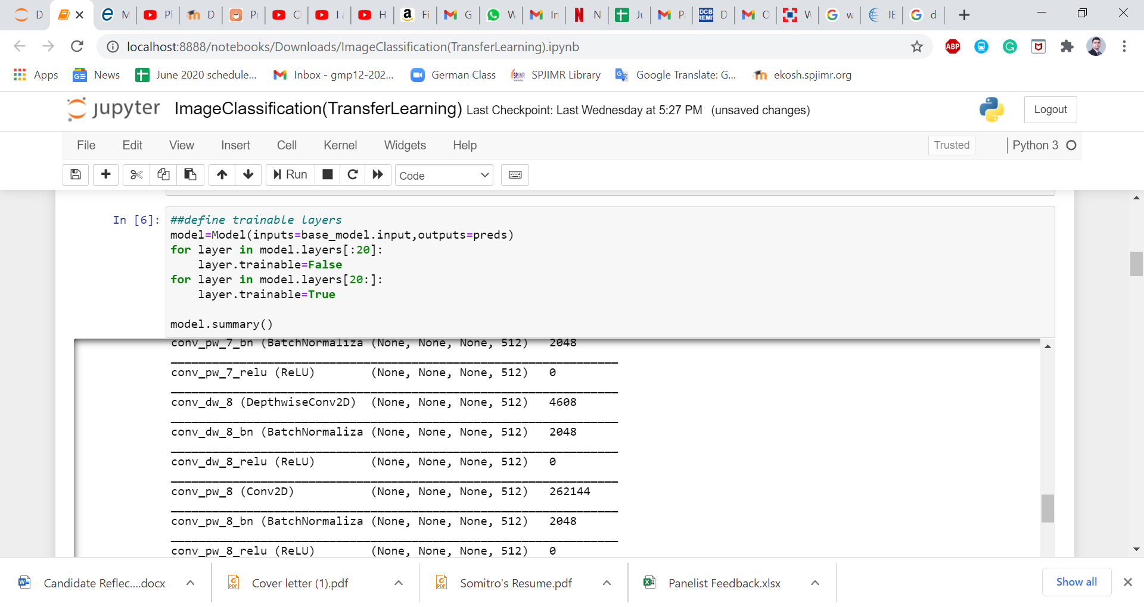We then define the trainable layers and see what our neural network looks like.

Model: "functional_3"

_________________________________________________________________

Layer (type) Output Shape Param #

=================================================================

input_2 (InputLayer) [(None, None, None, 3)] 0

_________________________________________________________________

conv1_pad (ZeroPadding2D) (None, None, None, 3) 0

_________________________________________________________________

conv1 (Conv2D) (None, None, None, 32) 864

_________________________________________________________________

conv1_bn (BatchNormalization (None, None, None, 32) 128

_________________________________________________________________

conv1_relu (ReLU) (None, None, None, 32) 0

_________________________________________________________________

conv_dw_1 (DepthwiseConv2D) (None, None, None, 32) 288

_________________________________________________________________

conv_dw_1_bn (BatchNormaliza (None, None, None, 32) 128

_________________________________________________________________

conv_dw_1_relu (ReLU) (None, None, None, 32) 0

_________________________________________________________________

conv_pw_1 (Conv2D) (None, None, None, 64) 2048

_________________________________________________________________

conv_pw_1_bn (BatchNormaliza (None, None, None, 64) 256

_________________________________________________________________

conv_pw_1_relu (ReLU) (None, None, None, 64) 0

_________________________________________________________________

conv_pad_2 (ZeroPadding2D) (None, None, None, 64) 0

_________________________________________________________________

conv_dw_2 (DepthwiseConv2D) (None, None, None, 64) 576

_________________________________________________________________

conv_dw_2_bn (BatchNormaliza (None, None, None, 64) 256

_________________________________________________________________

conv_dw_2_relu (ReLU) (None, None, None, 64) 0

_________________________________________________________________

conv_pw_2 (Conv2D) (None, None, None, 128) 8192

_________________________________________________________________

conv_pw_2_bn (BatchNormaliza (None, None, None, 128) 512

_________________________________________________________________

conv_pw_2_relu (ReLU) (None, None, None, 128) 0

_________________________________________________________________

conv_dw_3 (DepthwiseConv2D) (None, None, None, 128) 1152

_________________________________________________________________

conv_dw_3_bn (BatchNormaliza (None, None, None, 128) 512

_________________________________________________________________

conv_dw_3_relu (ReLU) (None, None, None, 128) 0

_________________________________________________________________

conv_pw_3 (Conv2D) (None, None, None, 128) 16384

_________________________________________________________________

conv_pw_3_bn (BatchNormaliza (None, None, None, 128) 512

_________________________________________________________________

conv_pw_3_relu (ReLU) (None, None, None, 128) 0

_________________________________________________________________

conv_pad_4 (ZeroPadding2D) (None, None, None, 128) 0

_________________________________________________________________

conv_dw_4 (DepthwiseConv2D) (None, None, None, 128) 1152

_________________________________________________________________

conv_dw_4_bn (BatchNormaliza (None, None, None, 128) 512

_________________________________________________________________

conv_dw_4_relu (ReLU) (None, None, None, 128) 0

_________________________________________________________________

conv_pw_4 (Conv2D) (None, None, None, 256) 32768

_________________________________________________________________

conv_pw_4_bn (BatchNormaliza (None, None, None, 256) 1024

_________________________________________________________________

conv_pw_4_relu (ReLU) (None, None, None, 256) 0

_________________________________________________________________

conv_dw_5 (DepthwiseConv2D) (None, None, None, 256) 2304

_________________________________________________________________

conv_dw_5_bn (BatchNormaliza (None, None, None, 256) 1024

_________________________________________________________________

conv_dw_5_relu (ReLU) (None, None, None, 256) 0

_________________________________________________________________

conv_pw_5 (Conv2D) (None, None, None, 256) 65536

_________________________________________________________________

conv_pw_5_bn (BatchNormaliza (None, None, None, 256) 1024

_________________________________________________________________

conv_pw_5_relu (ReLU) (None, None, None, 256) 0

_________________________________________________________________

conv_pad_6 (ZeroPadding2D) (None, None, None, 256) 0

_________________________________________________________________

conv_dw_6 (DepthwiseConv2D) (None, None, None, 256) 2304

_________________________________________________________________

conv_dw_6_bn (BatchNormaliza (None, None, None, 256) 1024

_________________________________________________________________

conv_dw_6_relu (ReLU) (None, None, None, 256) 0

_________________________________________________________________

conv_pw_6 (Conv2D) (None, None, None, 512) 131072

_________________________________________________________________

conv_pw_6_bn (BatchNormaliza (None, None, None, 512) 2048

_________________________________________________________________

conv_pw_6_relu (ReLU) (None, None, None, 512) 0

_________________________________________________________________

conv_dw_7 (DepthwiseConv2D) (None, None, None, 512) 4608

_________________________________________________________________

conv_dw_7_bn (BatchNormaliza (None, None, None, 512) 2048

_________________________________________________________________

conv_dw_7_relu (ReLU) (None, None, None, 512) 0

_________________________________________________________________

conv_pw_7 (Conv2D) (None, None, None, 512) 262144

_________________________________________________________________

conv_pw_7_bn (BatchNormaliza (None, None, None, 512) 2048

_________________________________________________________________

conv_pw_7_relu (ReLU) (None, None, None, 512) 0

_________________________________________________________________

conv_dw_8 (DepthwiseConv2D) (None, None, None, 512) 4608

_________________________________________________________________

conv_dw_8_bn (BatchNormaliza (None, None, None, 512) 2048

_________________________________________________________________

conv_dw_8_relu (ReLU) (None, None, None, 512) 0

_________________________________________________________________

conv_pw_8 (Conv2D) (None, None, None, 512) 262144

_________________________________________________________________

conv_pw_8_bn (BatchNormaliza (None, None, None, 512) 2048

_________________________________________________________________

conv_pw_8_relu (ReLU) (None, None, None, 512) 0

_________________________________________________________________

conv_dw_9 (DepthwiseConv2D) (None, None, None, 512) 4608

_________________________________________________________________

conv_dw_9_bn (BatchNormaliza (None, None, None, 512) 2048

_________________________________________________________________

conv_dw_9_relu (ReLU) (None, None, None, 512) 0

_________________________________________________________________

conv_pw_9 (Conv2D) (None, None, None, 512) 262144

_________________________________________________________________

conv_pw_9_bn (BatchNormaliza (None, None, None, 512) 2048

_________________________________________________________________

conv_pw_9_relu (ReLU) (None, None, None, 512) 0

_________________________________________________________________

conv_dw_10 (DepthwiseConv2D) (None, None, None, 512) 4608

_________________________________________________________________

conv_dw_10_bn (BatchNormaliz (None, None, None, 512) 2048

_________________________________________________________________

conv_dw_10_relu (ReLU) (None, None, None, 512) 0

_________________________________________________________________

conv_pw_10 (Conv2D) (None, None, None, 512) 262144

_________________________________________________________________

conv_pw_10_bn (BatchNormaliz (None, None, None, 512) 2048

_________________________________________________________________

conv_pw_10_relu (ReLU) (None, None, None, 512) 0

_________________________________________________________________

conv_dw_11 (DepthwiseConv2D) (None, None, None, 512) 4608

_________________________________________________________________

conv_dw_11_bn (BatchNormaliz (None, None, None, 512) 2048

_________________________________________________________________

conv_dw_11_relu (ReLU) (None, None, None, 512) 0

_________________________________________________________________

conv_pw_11 (Conv2D) (None, None, None, 512) 262144

_________________________________________________________________

conv_pw_11_bn (BatchNormaliz (None, None, None, 512) 2048

_________________________________________________________________

conv_pw_11_relu (ReLU) (None, None, None, 512) 0

_________________________________________________________________

conv_pad_12 (ZeroPadding2D) (None, None, None, 512) 0

_________________________________________________________________

conv_dw_12 (DepthwiseConv2D) (None, None, None, 512) 4608

_________________________________________________________________

conv_dw_12_bn (BatchNormaliz (None, None, None, 512) 2048

_________________________________________________________________

conv_dw_12_relu (ReLU) (None, None, None, 512) 0

_________________________________________________________________

conv_pw_12 (Conv2D) (None, None, None, 1024) 524288

_________________________________________________________________

conv_pw_12_bn (BatchNormaliz (None, None, None, 1024) 4096

_________________________________________________________________

conv_pw_12_relu (ReLU) (None, None, None, 1024) 0

_________________________________________________________________

conv_dw_13 (DepthwiseConv2D) (None, None, None, 1024) 9216

_________________________________________________________________

conv_dw_13_bn (BatchNormaliz (None, None, None, 1024) 4096

_________________________________________________________________

conv_dw_13_relu (ReLU) (None, None, None, 1024) 0

_________________________________________________________________

conv_pw_13 (Conv2D) (None, None, None, 1024) 1048576

_________________________________________________________________

conv_pw_13_bn (BatchNormaliz (None, None, None, 1024) 4096

_________________________________________________________________

conv_pw_13_relu (ReLU) (None, None, None, 1024) 0

_________________________________________________________________

global_average_pooling2d_1 ( (None, 1024) 0

_________________________________________________________________

dense_4 (Dense) (None, 1024) 1049600

_________________________________________________________________

dense_5 (Dense) (None, 1024) 1049600

_________________________________________________________________

dense_6 (Dense) (None, 512) 524800

_________________________________________________________________

dense_7 (Dense) (None, 6) 3078

=================================================================

Total params: 5,855,942

Trainable params: 5,820,038

Non-trainable params: 35,904

1. It’s time to load the images into the model for training. This is where we specify the path to our main folder.

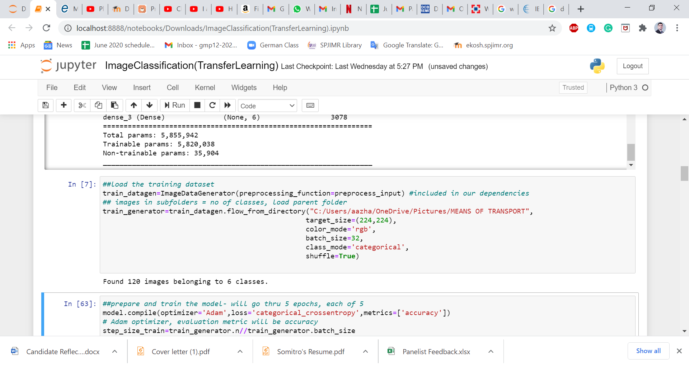

1. 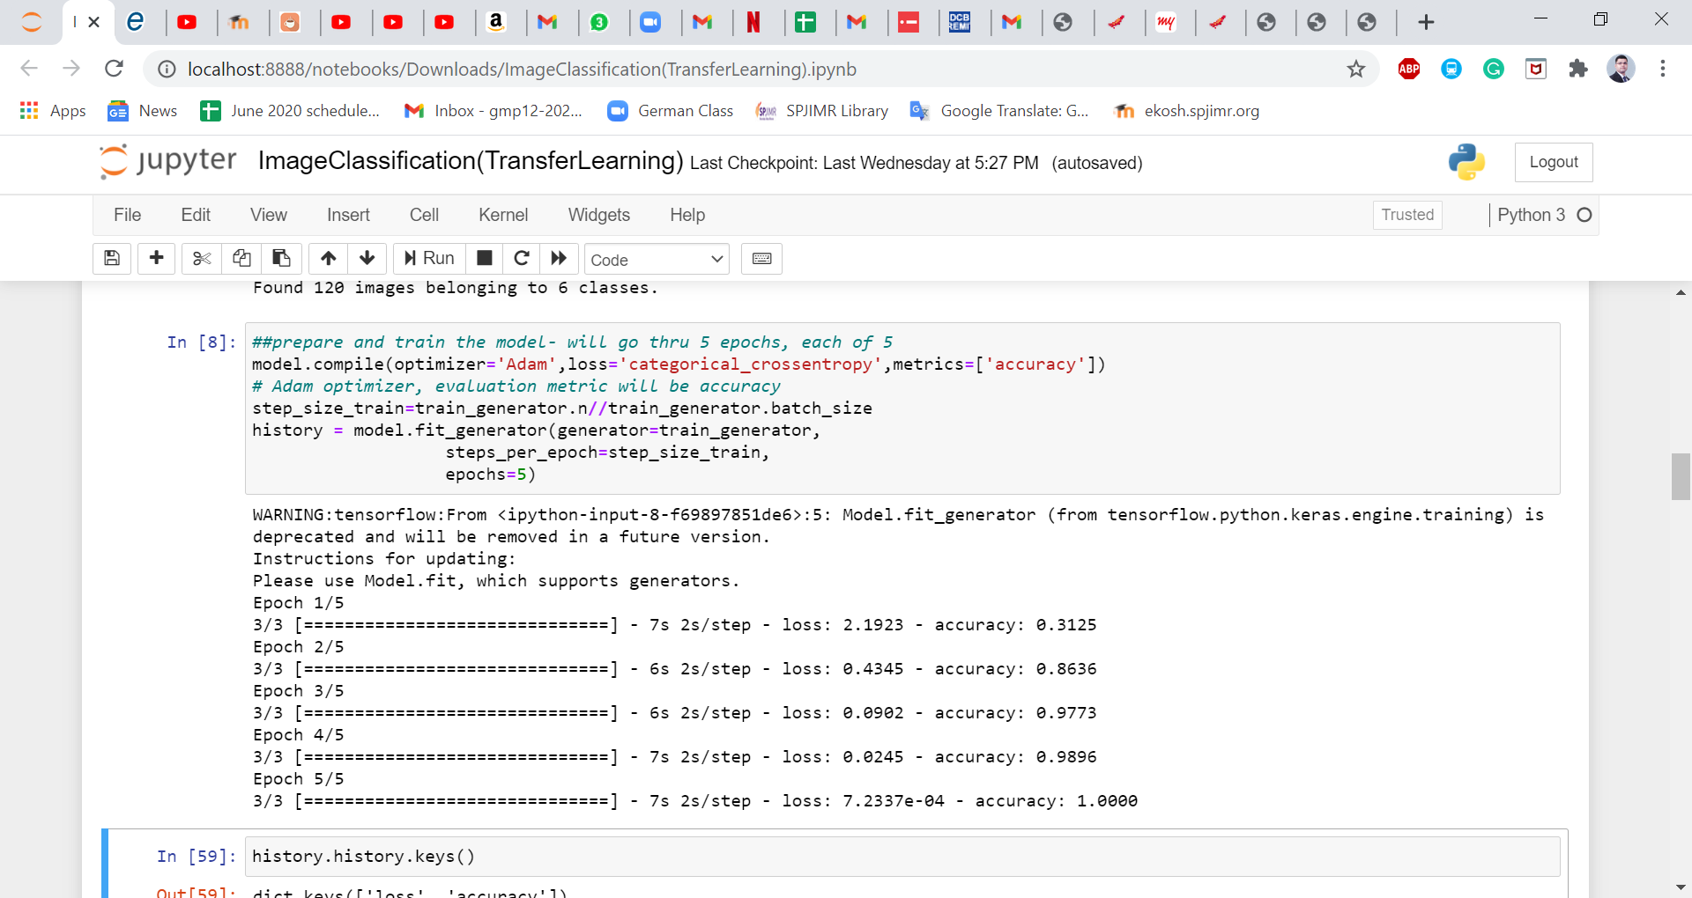We train the model using the loaded images and at the same time we store the accuracy and loss values at every epoch into a dictionary named as ‘history’.
2. 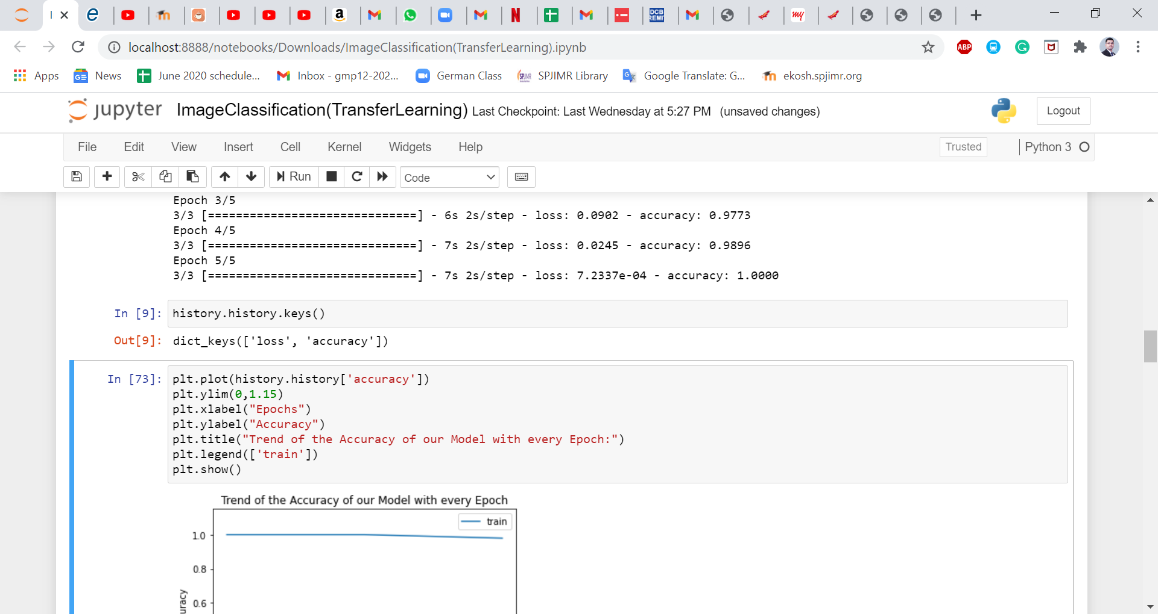Now we want to know the names of the keys inside the dictionary to be able to plot graphs.
3. After plotting the graph for accuracy using the matplotlib library, we see it increases with every epoch.

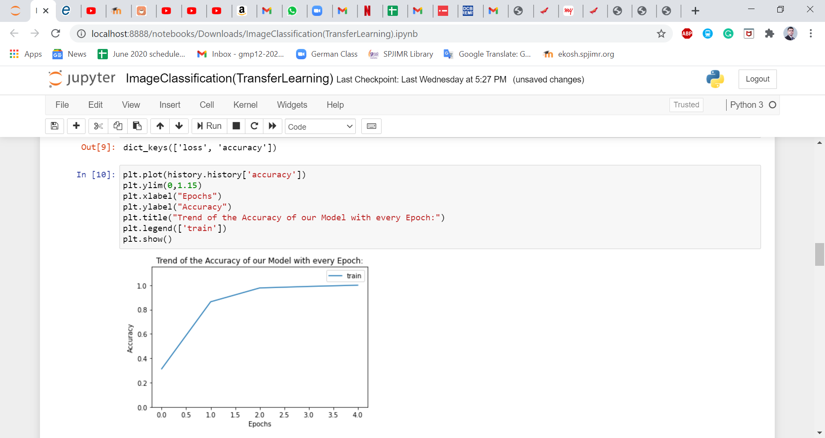

1. 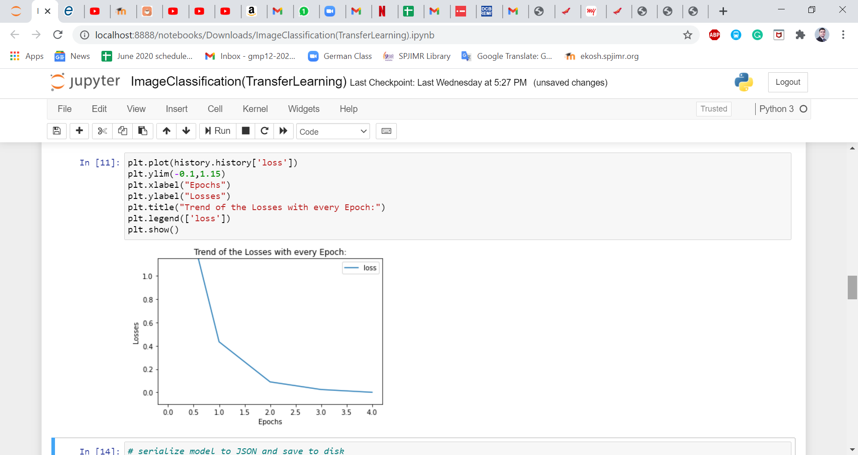 And the loss decreases with every epoch.
2. 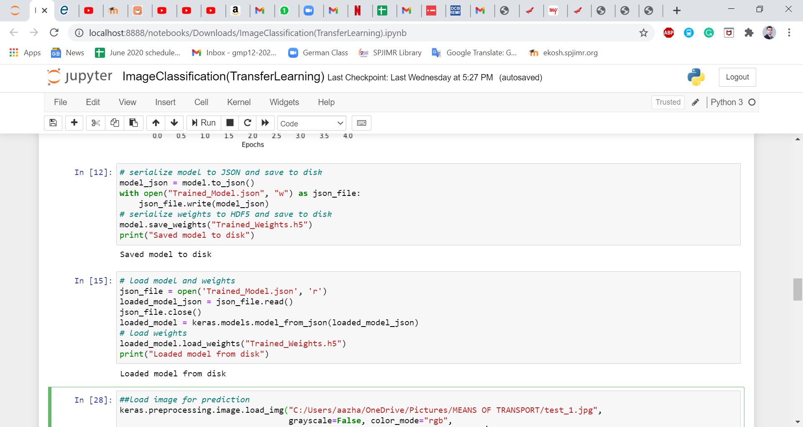 We save the trained model to disk with a .json extension and the weights with a .h5 extension
3. We load the saved model and weights and use it for testing.

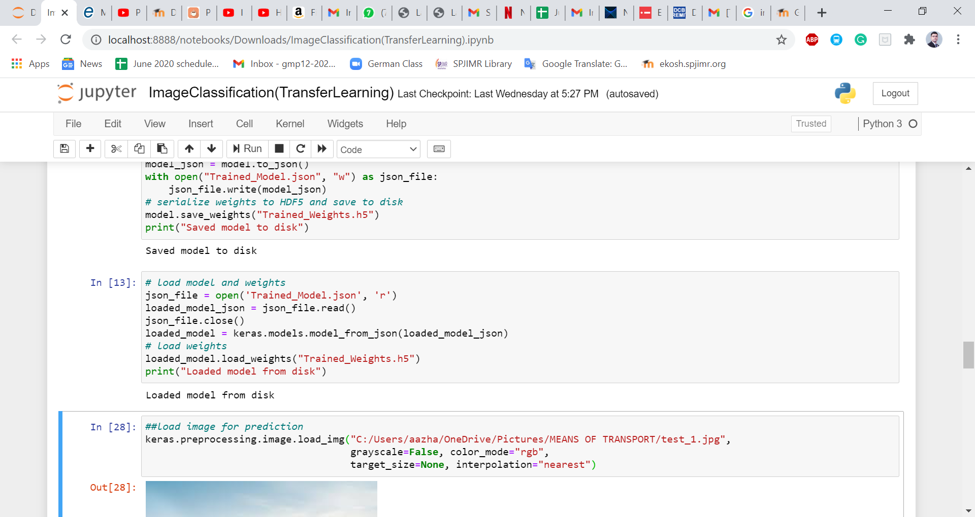

1. 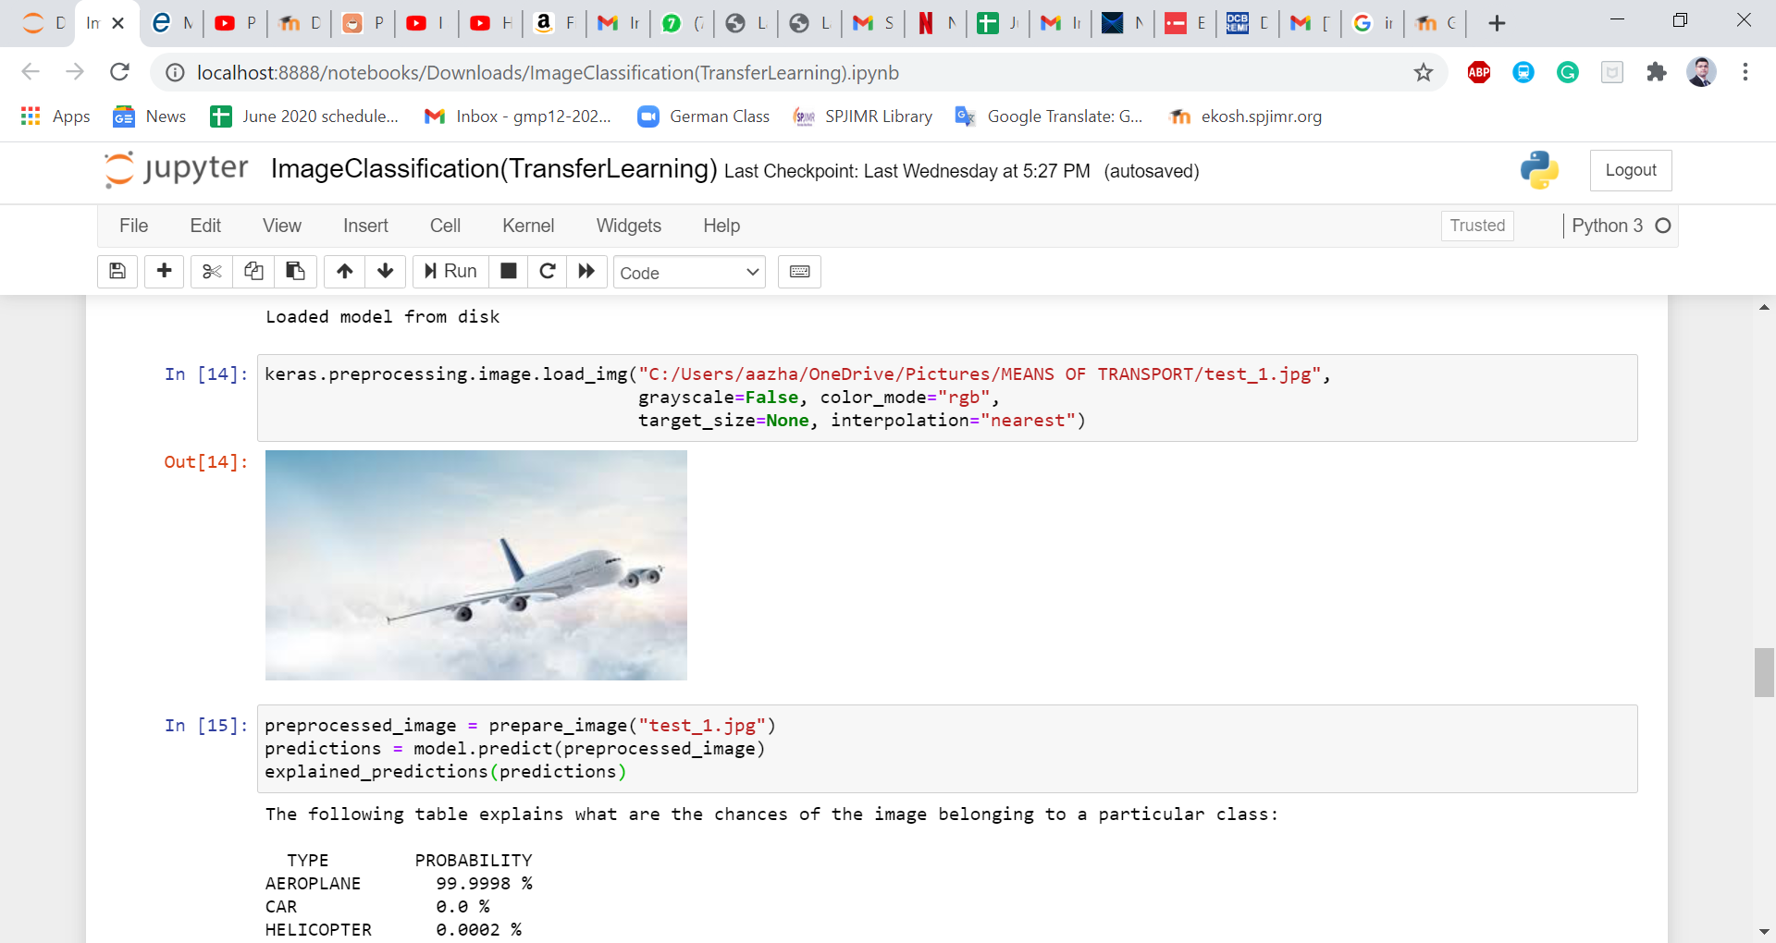 We load our 1st testing image.
2. 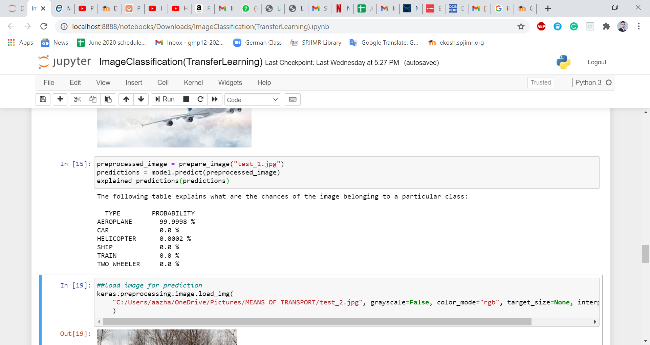 The image is preprocessed using our function prepare_image() on which our model makes predictions which finally are interpreted by another function explained_predictions() that also has been defined earlier.

We can see that our model has made a pretty good prediction given the fact that it has only been trained on 120 images only.

We had given a picture of an aeroplane and the model says that there is a 99.9998% chance that the image is that of an aeroplane and 0.0002% chance of it being a helicopter.

Therefore, we can conclude that the 1st image corresponds to an aeroplane.

The process is repeated to get the results for the rest of the four testing images.

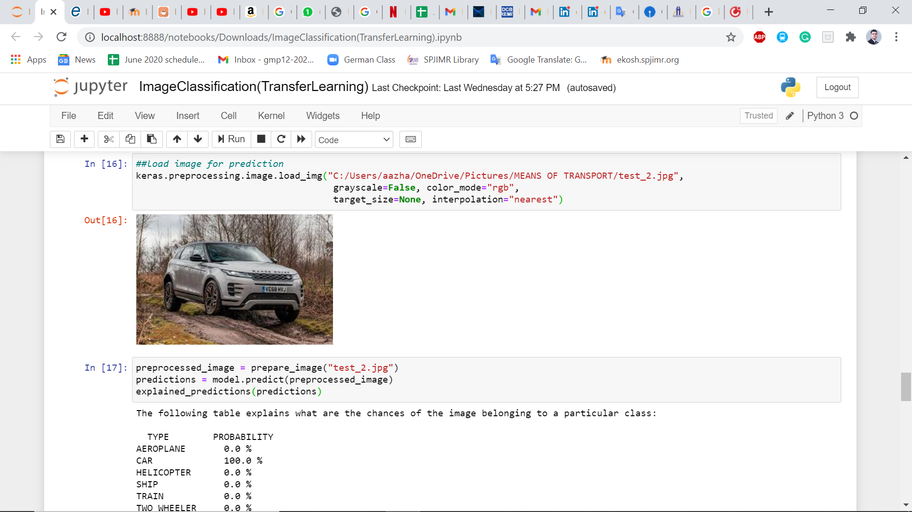2nd Test:

Therefore, we can conclude that the 2nd image corresponds to a car.

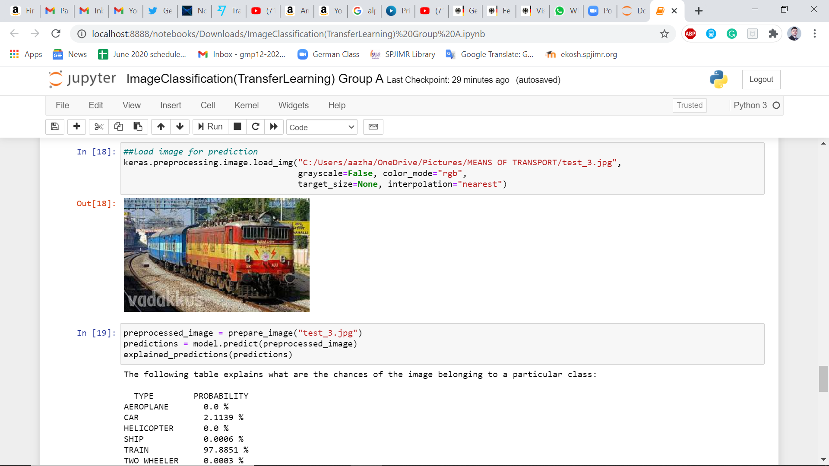3rd Test:

Therefore, we can conclude that the 3rd image corresponds to a train.

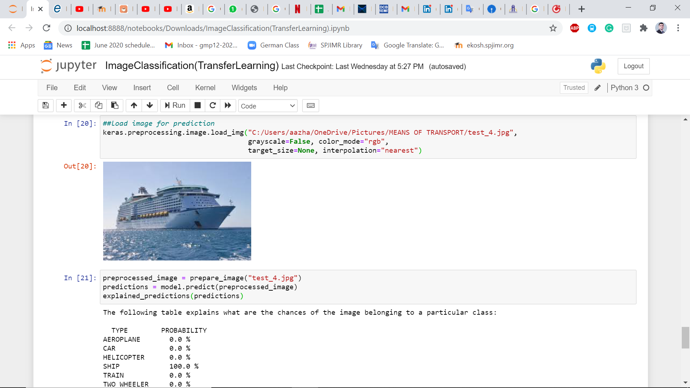4th Test:

Therefore, we can conclude that the 4th image corresponds to a ship.

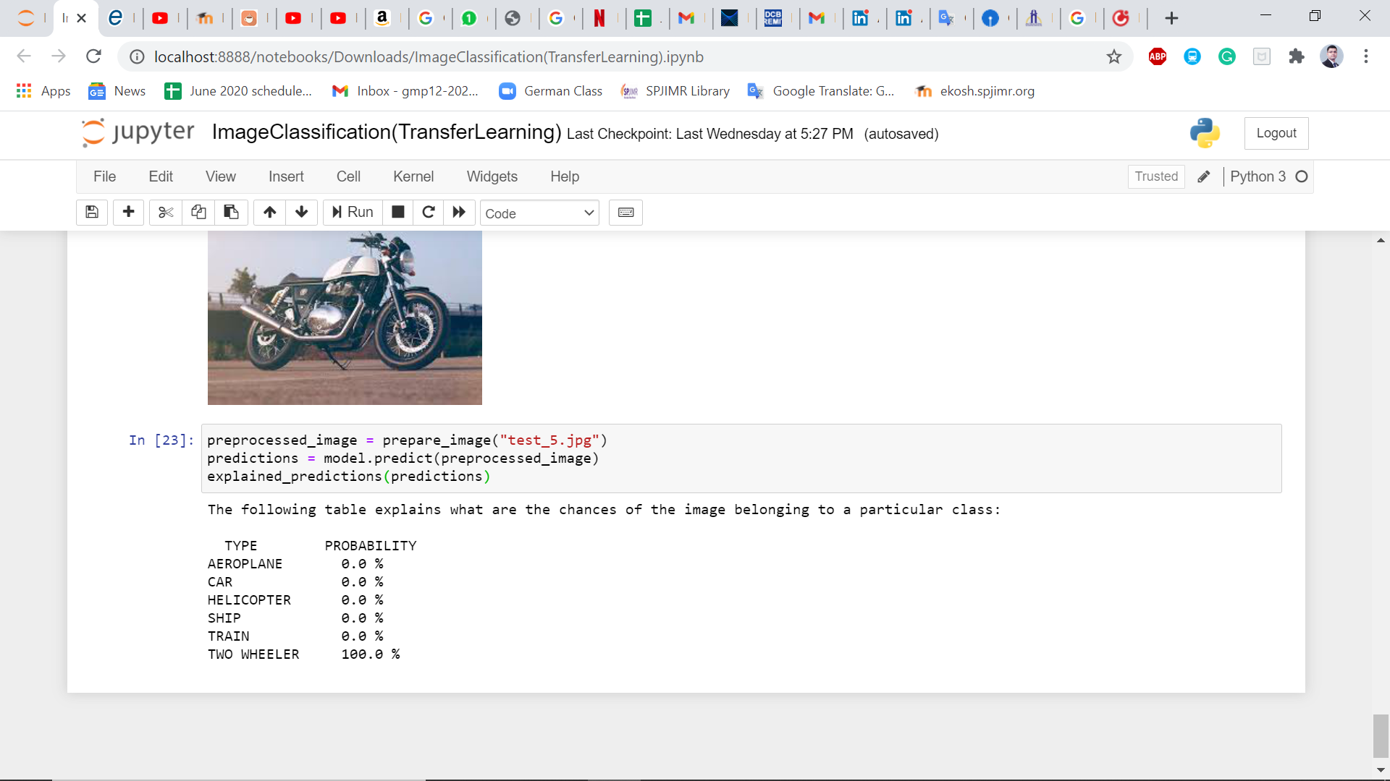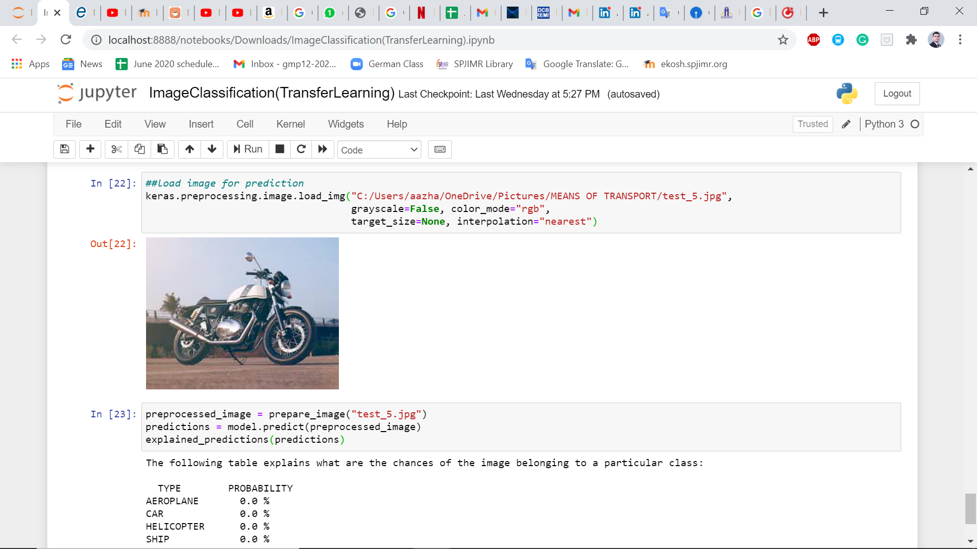5th Test:

Therefore, we can conclude that the 5th image corresponds to a two-wheeler.